
Dashboard Design

Date | 25 October 2026
Team ID | Individual
Project Name | EV Market Analysis
Maximum Marks | 5 Marks

Creating an effective dashboard involves thoughtful design to ensure that the presented information is clear, relevant, and easily understandable for the intended audience. Here are some key principles and best practices for dashboard design
Activity 1: Interactive and visually appealing dashboards
Creating interactive and visually appealing dashboards involves a combination of thoughtful design, effective use of visual elements, and the incorporation of interactive features. Here are some tips to help you design dashboards that are both visually appealing and engaging for users so take care of below points
- Clear and Intuitive Layout
- Use Appropriate Visualizations
- Colour and Theming
- Interactive Filters and Slicers
- Drill-Down Capabilities
- Responsive Design
- Custom Visuals and Icons
- Use of Infographics

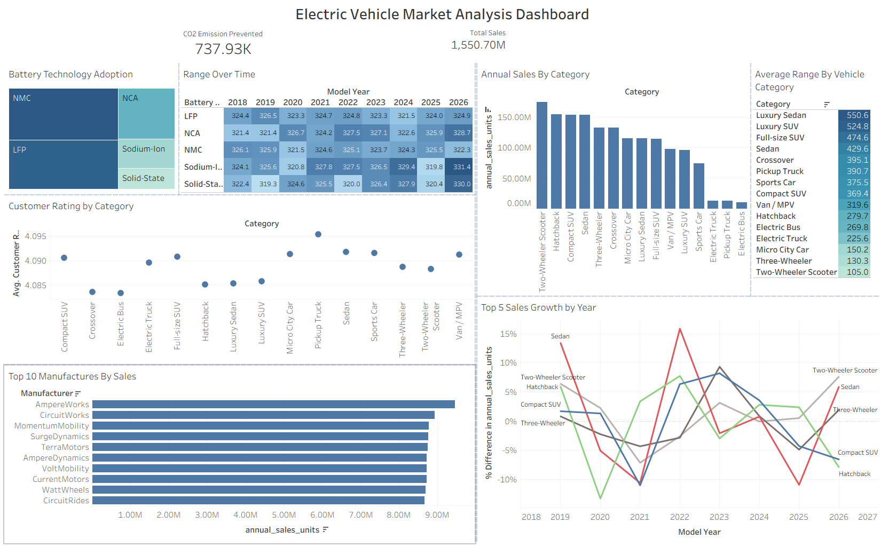
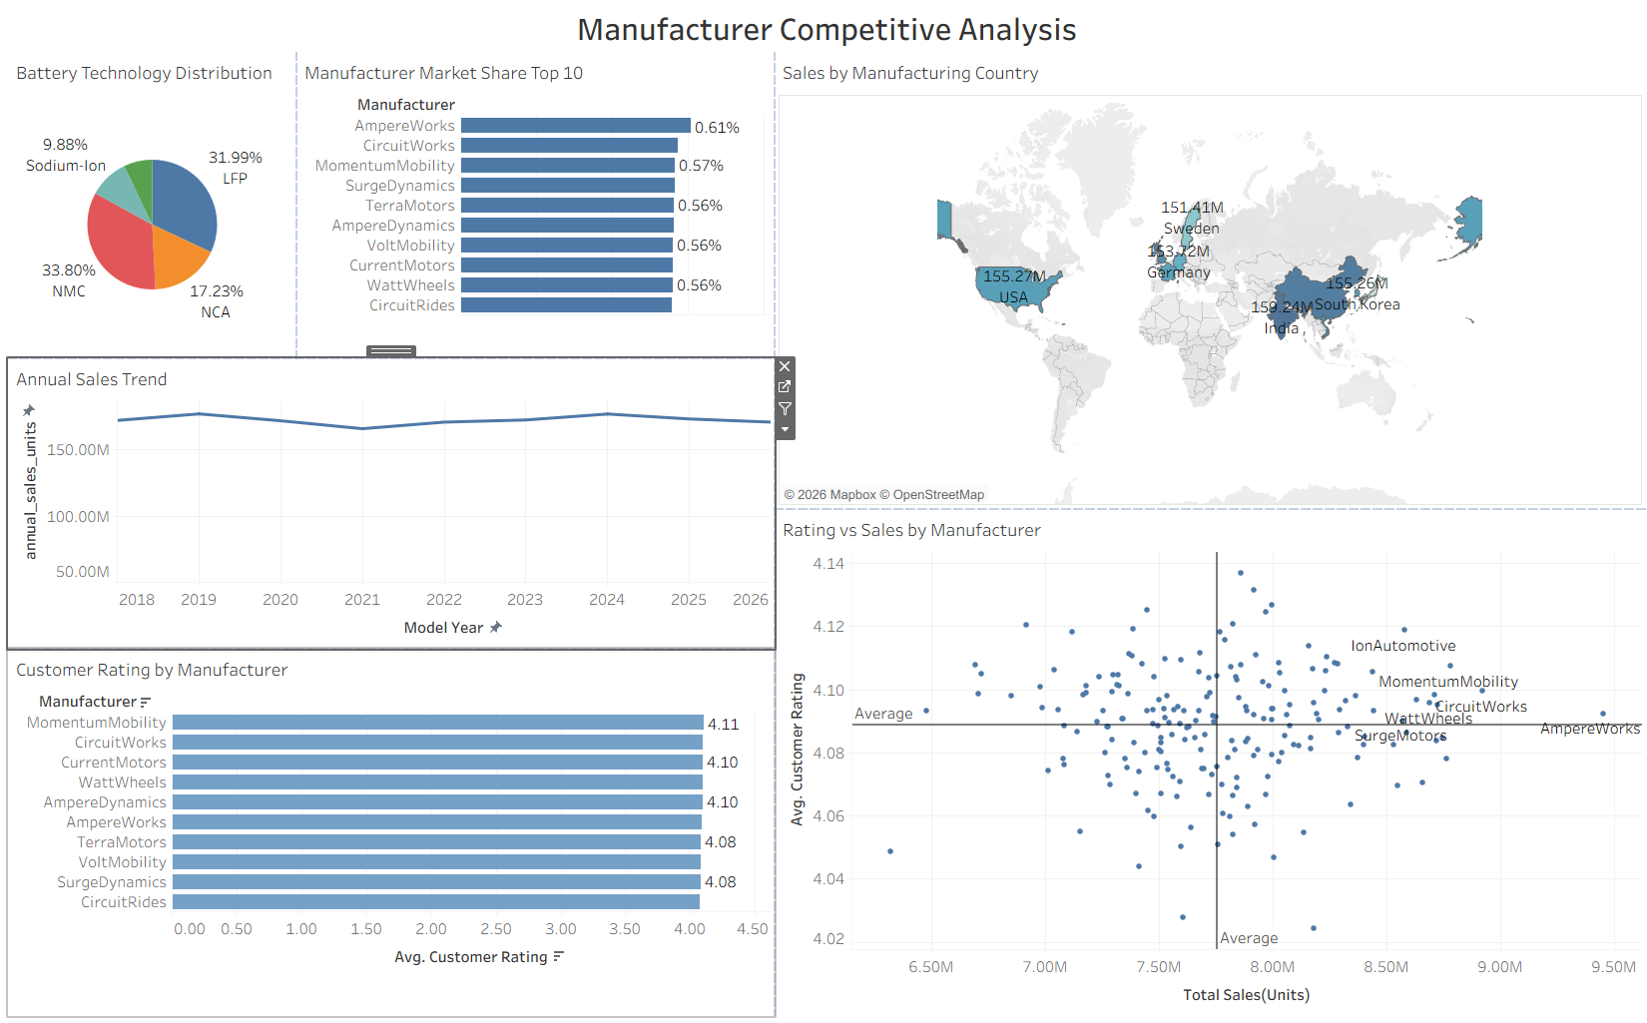
Major outcomes from the Electric Vehicle Market Analysis and Manufacturer Competitive Analysis dashboards:
- Sales and Sustainability Overview: The dashboards report total sales of 1,550.70M units and 737.93K of CO2 emission prevented, showing the overall scale and environmental impact of the EV market.
- Top-Selling Categories: Two-Wheeler Scooter, Hatchback, Compact SUV and Sedan lead annual sales, while Electric Truck, Pickup Truck and Electric Bus have the lowest sales.
- Battery Technology Adoption: NMC (33.80%) and LFP (31.99%) dominate the market, followed by NCA (17.23%) and Sodium-Ion (9.88%). Average range stays close to 320-331 across battery types and model years.
- Range Leaders: Luxury Sedan (550.6) and Luxury SUV (524.8) have the highest average range, while Two-Wheeler Scooter (105.0) and Three-Wheeler (130.3) have the lowest.
- Evenly Spread Manufacturer Market: AmpereWorks leads in sales and market share (0.61%), followed by CircuitWorks and MomentumMobility, but the top 10 manufacturers all sit between about 0.56% and 0.61%.
- Customer Satisfaction and Production: Customer ratings are tightly grouped (about 4.08 to 4.11), with MomentumMobility rated highest among top manufacturers, and manufacturing sales are spread across countries, with India highest at 159.24M.

Activity 2
Publish Dashboard on Tableau Public and Paste the Dashboard Public link below:
Example
https://public.tableau.com/app/profile/hussain.saifee5441/viz/EVMarketAnalysis_17930983632520/ElectricVehicleMarketAnalysisDashboard?publish=yes&showOnboarding=true

